**Integration Testing**

**Introduction:**

Integration testing is a comprehensive, end-to-end test of the integration of subsystems and interfaces. The purpose of integration testing is to verify proper coordinated functioning of the modules that make up a sub-system. The focus of integration testing is on cross-functional tests rather than on unit tests within one module.

The approach to integration testing should model the actual usage of the application in production. Valid business processes, including inputs and outputs, are executed and validated.

**Test Cases and Results:**

**Basic User**

|  |  |  |  |  |  |  |  |  |
| --- | --- | --- | --- | --- | --- | --- | --- | --- |
|  |  |  | **Observed Behavior \*** | | | | | |
| **#** | **Data Input** | **Expected Behavior/Action Goal** | **Run 1** | | **Run 2** | | **Run 3** | |
|  |  |  | **(P/F)** | **H/M/L** | **(P/F)** | **H/M/L** | **(P/F)** | **H/M/L** |
|  | To check whether the user can login successfully into the system | The user logs into the system successfully | P | L | P | L | P | L |
|  | To check whether the user can login to the system without entering a password or entered an incorrect password | The user cannot login to the system. | F | H | F | H | P | L |
|  | To check whether the user can login to the system without entering the email ID | The user cannot login to the system | F | H | P | L | P | L |
|  | To check whether the user can login to the system without entering email ID and password | The user cannot login to the system | F | H | P | L | P | L |
|  | To check whether the user can login to the website without entering an email id for Facebook login | The user cannot login to the system. | P | M | P | M | PP | L |
|  | To check whether the user can login to the website without entering password for Facebook login | The user cannot login to the system. | P | M | P | L | P | L |
|  | To check whether the user can register without entering his first name | The user cannot register to the website. | P | M | P | L | P | L |
|  | To check whether the user can register without entering his last name | The user cannot register to the website. | F | H | F | L | P | L |
|  | To check whether the user can register without entering his email id | The user cannot register to the website. | F | H | F | M | P | L |
|  | To check whether the user can register without entering his password and confirming it | The user cannot register to the website. | F | H | P | L | P | L |
|  | To check whether the user can plan a trip without entering his start date | The user cannot plan his trip. | F | H | F | H | P | L |
|  | To check whether the user can plan a trip without entering his end date | The user cannot plan his trip. | F | H | F | H | P | L |
|  | To check whether the user can plan a trip without entering his destination | The user cannot plan his trip. | F | H | P | L | P | L |
|  | To check whether the user can plan a trip without entering his appropriate currency | The user cannot plan his trip. | P | M | P | L | P | L |
|  | To check whether the user can plan a trip without entering his preferences | The user cannot plan his trip. | P | L | P | L | P | L |
|  | To check whether the user can plan a trip without entering his default time format | The user cannot plan his trip. | F | H | P | M | P | L |
|  | To check whether the user can communicate with customer care without entering his first name | The user cannot send a message | P | M | P | M | P | L |
|  | To check whether the user can communicate with customer care without entering his last name | The user cannot send a message | P | L | P | L | P | L |
|  | To check whether the user can communicate with customer care without entering his email id and phone number | The user cannot send a message | F | M | P | L | P | L |
|  | To check whether the user can plan a trip without entering his message description | The user cannot send a message | F | H | P | M | P | L |

**Integration Test cases:**

|  |  |
| --- | --- |
| **Task** | **Description** |
| **T1**  Start:  End:  Frequency:  Difficulty:  **Steps**:  1.  2.  3. | **Planning a trip**  User has to give start date, end date and destination as input  View the iteinerary page  One time, after the application is launched  Simple  Open Paperplane website on a personal computer or any mobile device  Supply necessary inputs and click on search button  By clicking search button, User can view his planned trip |
| **T2**  Start:  End:  Frequency:  Difficulty:  **Steps**:  1.  2.  3. | **Adding default currency, time format and travel preferences**  User has to launch the settings page  Modify them based on user’s time format and usage of currency  One time, after the application is launched  Simple  Open Paperplane website on a personal computer or any mobile device  Click the settings button in the navigation menu on the home page  Click on respective fields and set travel preferences |
| **T3**  Start:  End:  Frequency:  Difficulty:  **Steps**:  1.  2. | **Registration for an account and Logging in**  Login/sign up page of the application using navigation bar  Successful registration and login  One time, after the application is launched  Simple  Open login/sign up page of the application  Enter all required fields for registration or directly login using credentials. |
| **T4**  Start:  End:  Frequency:  Difficulty:  **Steps**:  1.  2.  3.  4.  5. | **Have a chat with paper plane customer support team**  Home page of the application  Completion of chat with customer support  One time, after the application is launched  Medium  Open Home page of the application  Scroll down to the bottom of the page  Fill in all the necessary fields  Send a message to the customer support team  Click on logout button |

**T1 screenshot:**

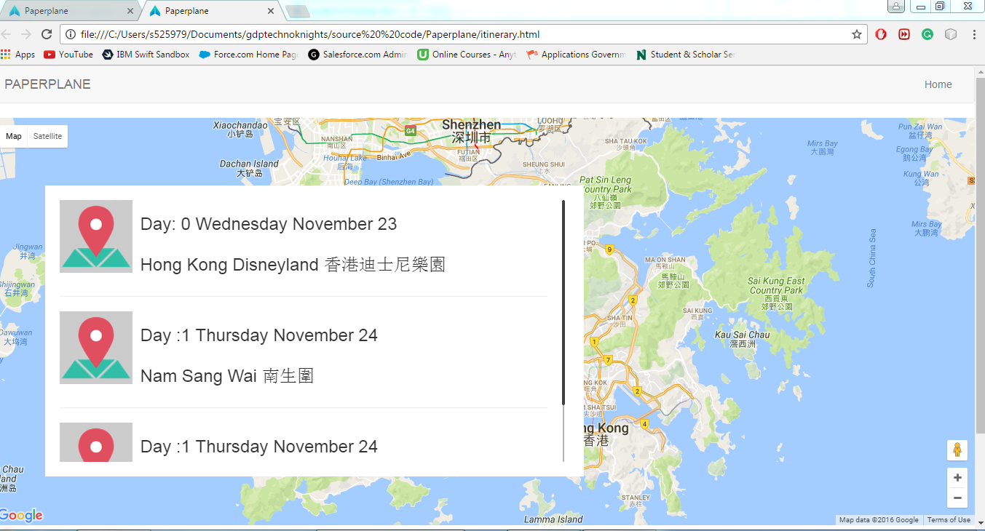

**T2 screenshot:**

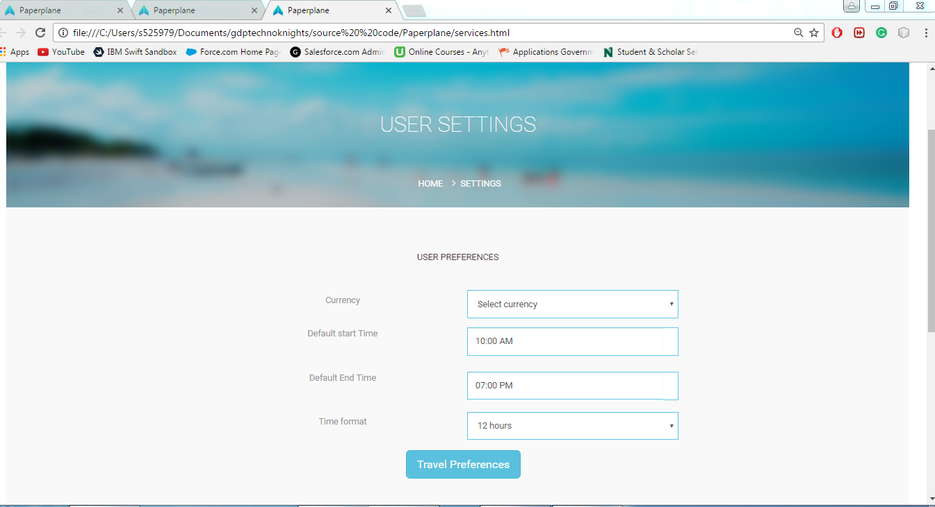

**T3 screenshot:**

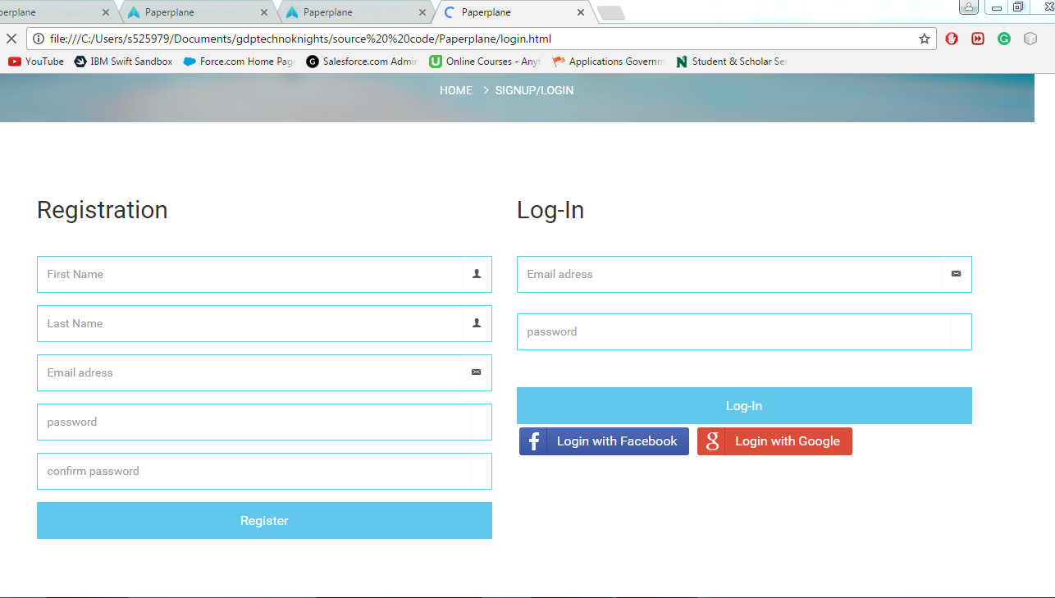

**T4 screenshot:**

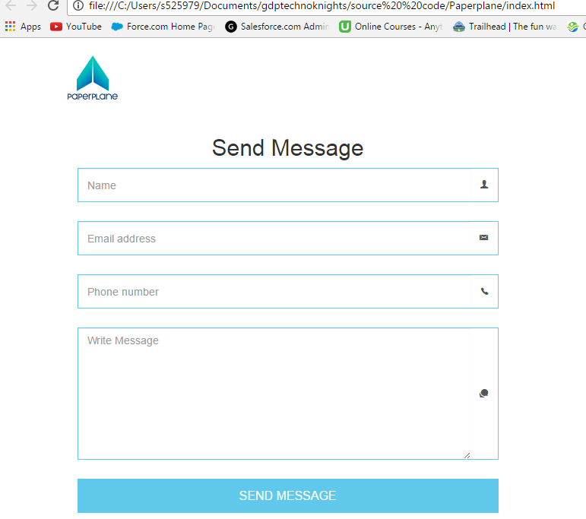

**Team Contribution:**

|  |  |
| --- | --- |
| **Team Member** | **%Contribution** |
| Vamshinath Nallamothu | 15% |
| Hima teja Gutta | 10% |
| Bhanu Teja Kurucheti | 15% |
| Sravya Madarapu | 10% |
| Sai Sumanth Kottekola | 10% |
| Adarsh Kumar Reddy Pidaparthy | 20% |
| Sai Raj Kiran Kandula | 20% |